Running configurations
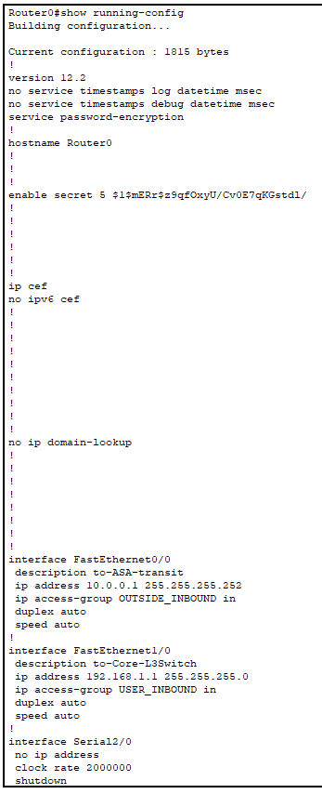
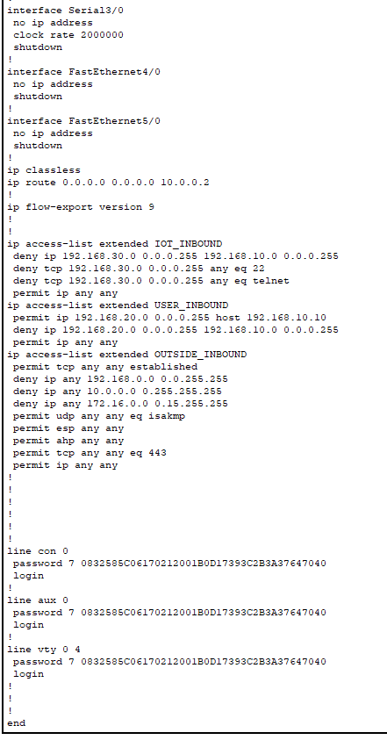
- Router0 configuration

L2 Switch
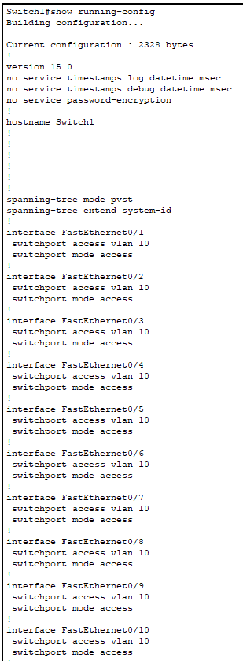
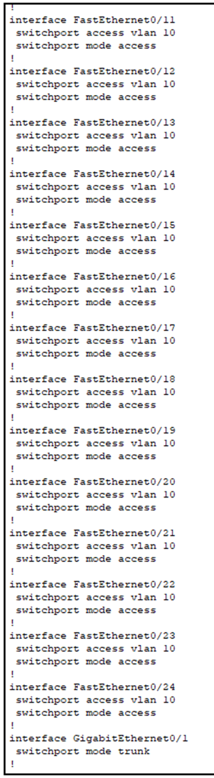

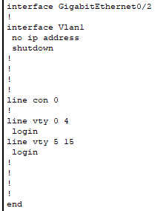
Vlan 10 configuration

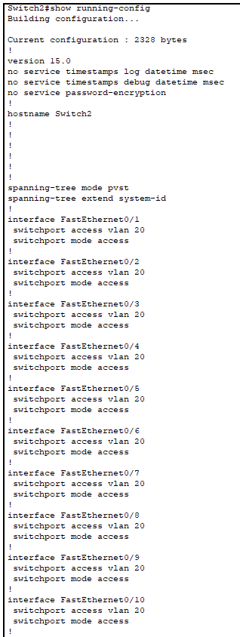

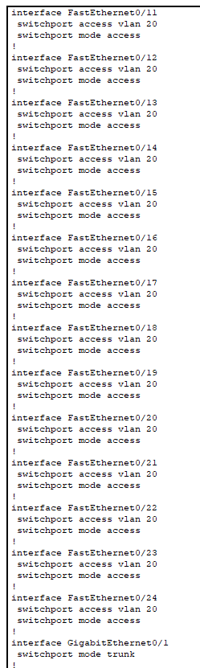

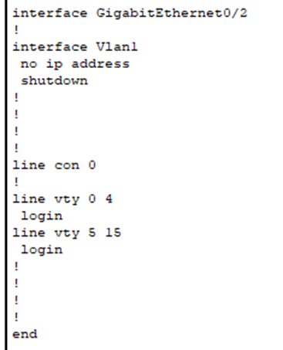
Vlan 20 configuration

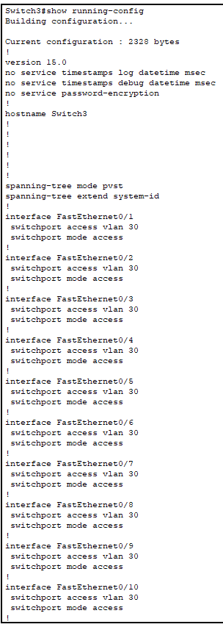

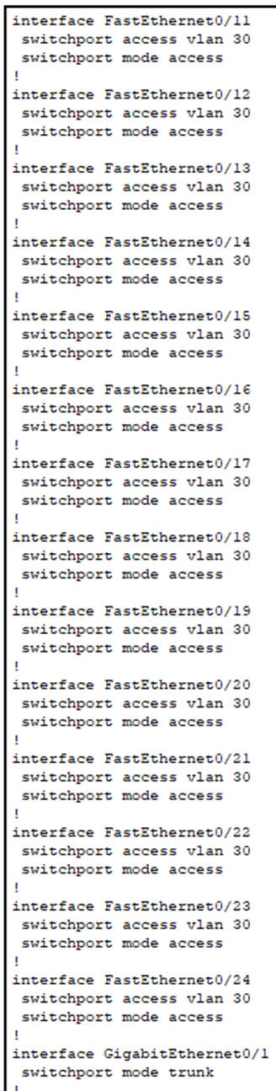

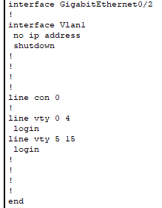
Van 30 configurations

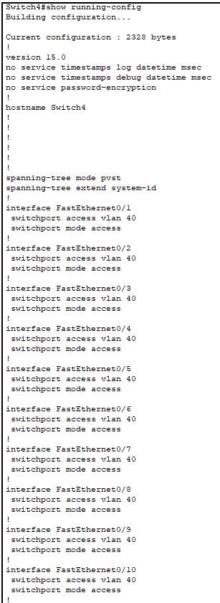

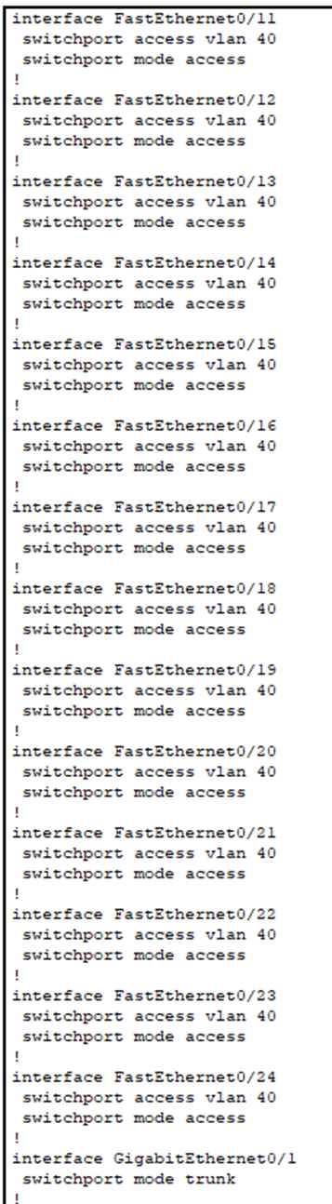

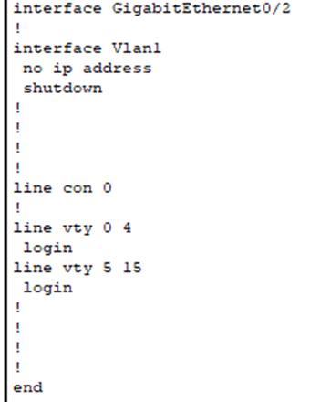
Vlan 40 configuration

Multilayer Switch0

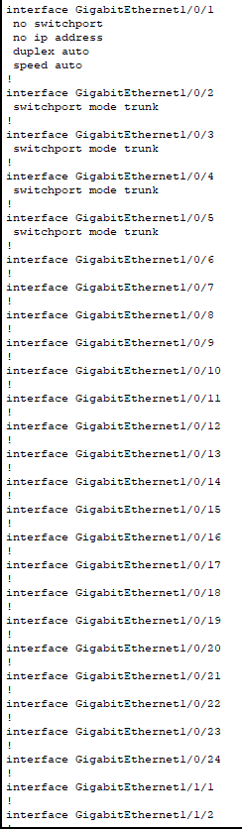

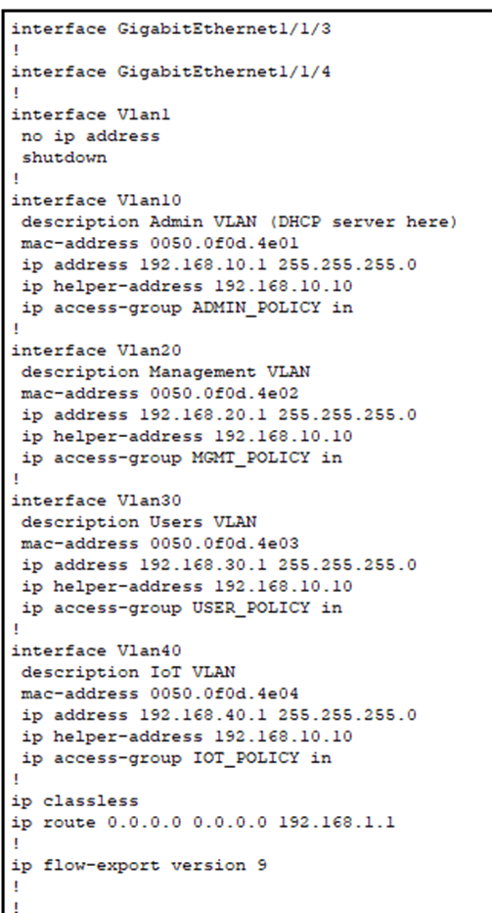

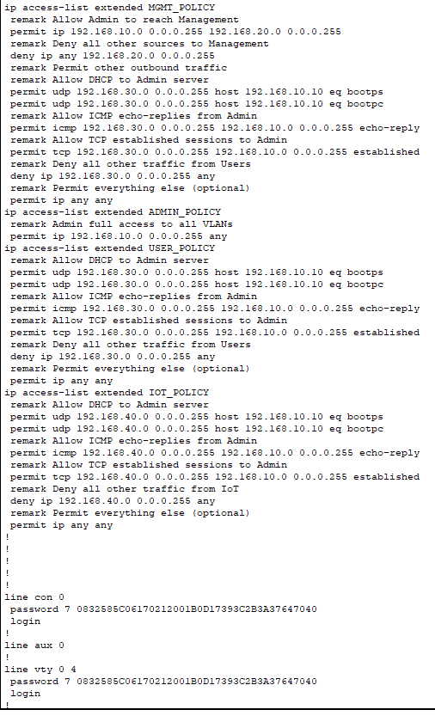
Multilayer Switch running Configurations

ASA configurations
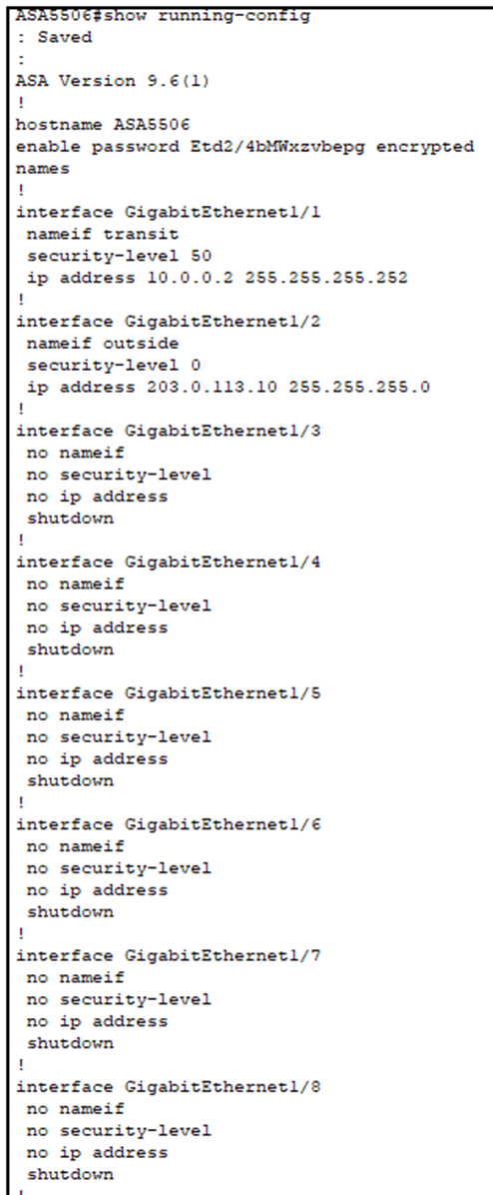

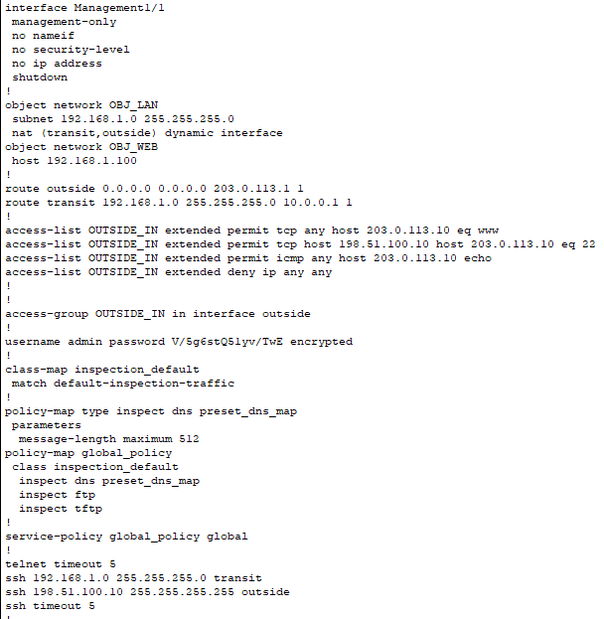
ASA running Configurations
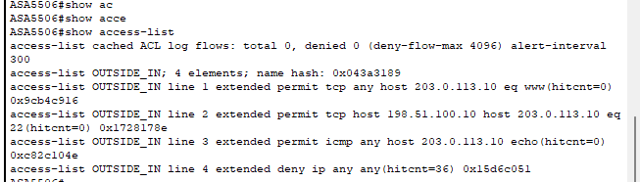
Firewall access list hit

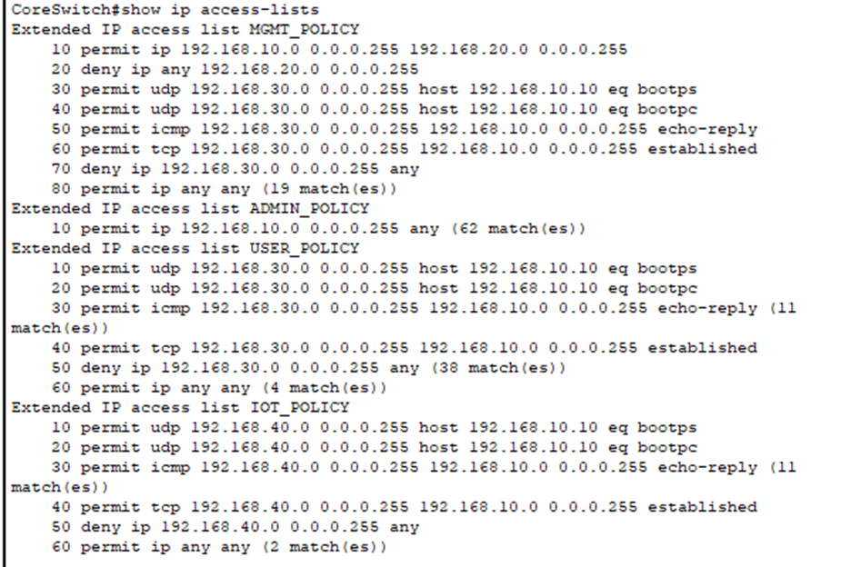
IP Access Lost to confirm ACL Hits

Internal Network
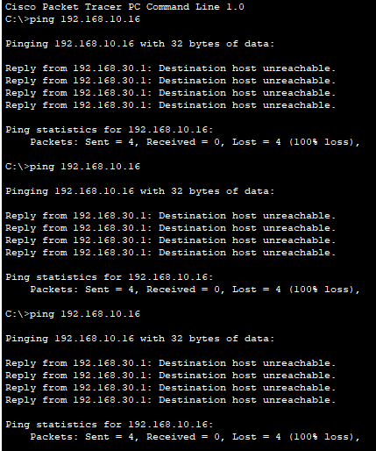
Ping inside attacker vlan 30 to PC1(Vlan 10) status: failed
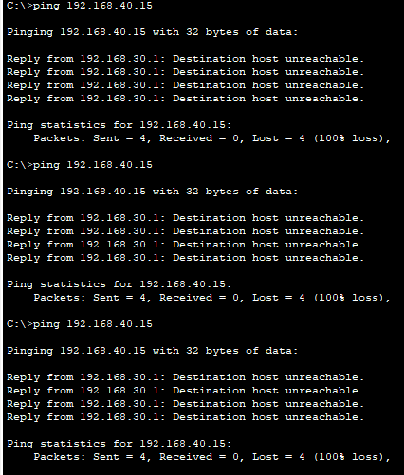
Ping inside attacker vlan 30 to IoT3(VLAN 30) status: failed

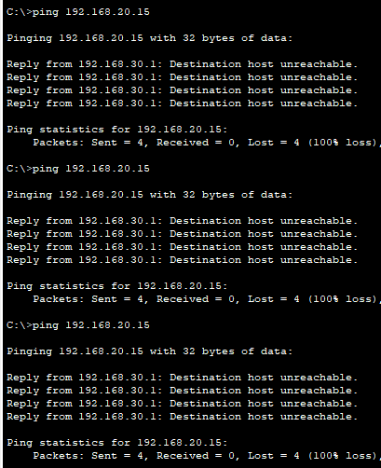
Ping inside attacker vlan 30 to PC4(20) status: failed

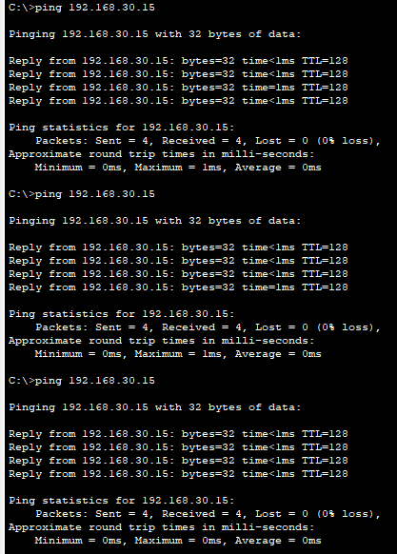
Ping inside attacker vlan 30 to PC5(VLAN30) status: success

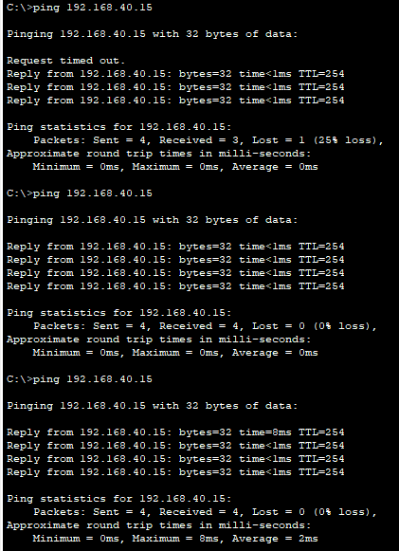
Ping PC1 VLAN 10 to IoT3 Vlan40 Status: success

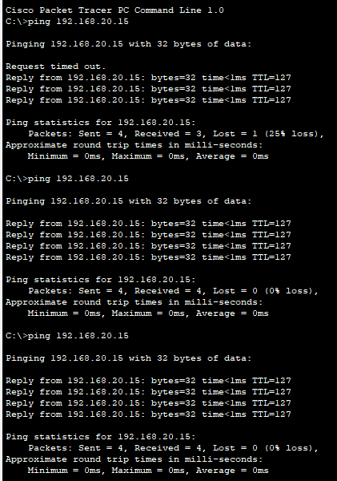
Ping PC1 VLAN 10 to PC4 Vlan20 Status: success

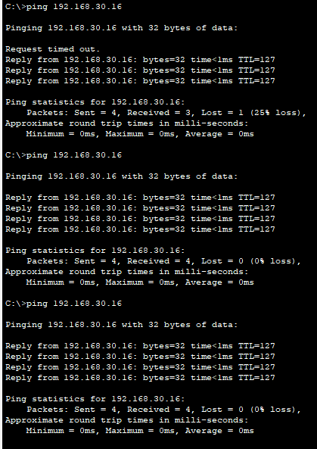
Ping PC1 VLAN 10 to PC5Vlan30 Status: success

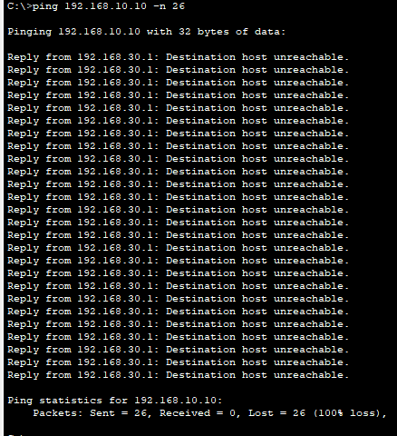
Inside DoS attack attempt Status: fail

Test Outside Attacker

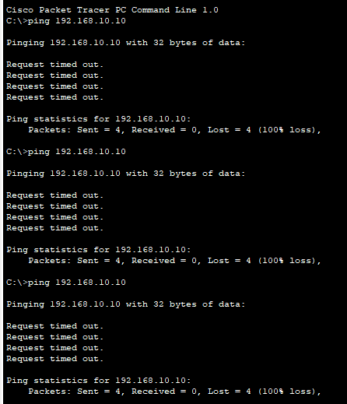
Ping from outside attacker to dhcp server status: fail

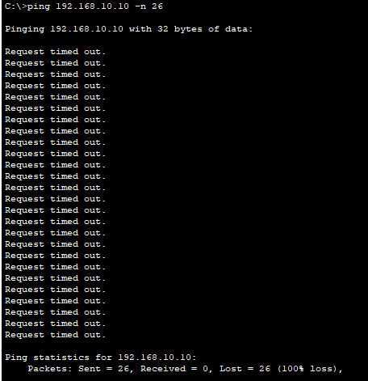
Outside DoS attack attempt status: fail

